Demographic entrapment
The phenomenon and theory of the demographic transition refers to the historical shift in demographics from high birth rates and high infant death rates in societies with minimal technology, education (especially of women) and economic development, to demographics of low birth rates and low death rates in societies with advanced technology, education and economic development, as well as the stages between these two scenarios (see illustration below). Although this shift has occurred in many industrialized countries, the theory and model are frequently imprecise when applied to individual countries due to specific social, political and economic factors affecting particular populations.[1] Thomas Malthus had famously predicted that with geometric population growth, human need (human greed, my edits) could eventually outstrip Earth’s resources. Despite its weaknesses, the Malthusian doctrine contains much truth and it is especially applicable to most of the LMICs where populations are on the increase and food productions, due to one or the other reason, has not kept pace with the increase in population. Human population has increased exponentially from less than 1 billion in 1800 to 7.8 billion today.[2]
Almost thirty years back Maurice King described the concept of demographic trap in the Lancet.[3] King and Elliot further pointed out that our worst problem is demographic entrapment and refusal to contemplate human overpopulation as a problem. Humans have a problem with controlling population and refuse to consider or discuss population control. [4] They went on to state that Hardinian taboo, refusal to contemplate overpopulation, is a problem. If the Hardinian taboo on entrapment is not removed, giving an example of Rwanda, there will be increasing slaughter and starvation throughout much of Africa and elsewhere. Lifting the taboo has important implications for the market economy and lifting it would be a powerful agent for good. Today’s advances in information technology and artificial intelligence and the use of the world wide web could be the key factors in lifting it. However, to this day the urgency of the matter conveyed by public health experts and epidemiologists, has not been addressed seriously. The special BMJ issue, under education and debate, which was both controversial and innovative, discussed concept of demographic entrapment and overconsumption. (see second article in reference 4 below)
Periodic debate on the subject has been explosive but the actions have been rather muted.[5] [6] [7] Paradoxically, those who can afford to have many children are opting for just one or two but those who can ill afford are having many. There is ample of literature on the subject and the urgency is to disseminate this information as much as possible and encourage debate at every level so that the earnestness of the matter is recognized and each one of us do something about it. Many ideals are described for our future through a healthy environment and family and it will never be possible for all to accept everything. But if our efforts are geared to the systems that governs our society, there is a possibility that significant number of people will adopt some of these ideals to make a difference. Often finger is pointed at others for not acting or doing what is required. However, each one of us have to do something about it and cumulative difference may be significant:
- There is only one planet Earth where we can live today and we have a responsibility to live with care and leave it livable for generations that follow, because our greed can starve our children (carrying capacity or our planet);
- Education has made a big difference and will continue to do so in future, and hence universal education is a must. Education should not be restricted to literacy and numeracy but there is an urgent need to include awareness and knowledge of how our body functions, especially procreation, and the preservation of our environment for ourselves and for the future generations;
- Family planning should be seen as a sincere plan to decide taking a serious commitment and responsibility of having a child and ensuring that the child grows into a self-reliant responsible adult;
- Bringing up a child requires great care and love and it starts from the day decision has been made to have a baby. Parents have a responsibility to equip themselves with the knowledge to provide appropriate optimal care, including nutrition. Care takers and the society at large have an important role to play. Ken Robinson in The Element reminds us that they say, ‘it takes a village to raise a baby’;
- Age at which a woman bears a child is important, not only because of the dangers associated with birth during adolescent years, but also for the ability to be a responsible parent and capable of fulfilling parental responsibility towards the child’s needs;
- Questionable cultural and religious influences interfere with the survival and prosperity of men and women. Followers should be allowed to question and be free to take responsible decisions independently;
- Health workers have a major role to play. Illness care is essential but preventive advice is an important part of the treatment. Every opportunity should be used to link family planning with better health;
- Governments have a responsibility in protecting their countries, eventually this Earth but we make our governments and the process start at individual level.
Previous posting under Home > Old Articles on this website related to this theme are:
May 25, 2019: Family Planning
June 1, 2019: Preventing teenage pregnancy
July 14, 2019: Preconception Health
July 28, 2019: Critical need of responsible men for a Healthy Society
​October 12, 2019: Reduction in Maternal Mortality
Visit also: Under More > Maternal and Child Health > Maternal health: Maternal mortality - a case study
References
[1] https://en.wikipedia.org/wiki/Demographic_transition
[2] World population clock. https://www.worldometers.info/world-population/
[3] Maurice King. Demographic Trap. Lancet Vol 337. February 2, 1991.
[4] Maurice King & Charles Elliott. To the point of farce: a Martian view of the Hardinian taboo—the silence that surrounds population control. BMJ 1997;315: 1441-3.
[5] Contrasting views on human population growth. BMJ 1999; 319: 931
[6] Deborah J. Anderson, Ph.D. Population and the Environment — Time for Another Contraception Revolution. N Engl J Med 2019; 381:397-399
[7] Colin D. Butler. Climate Change, Health and Existential Risks to Civilization: A Com
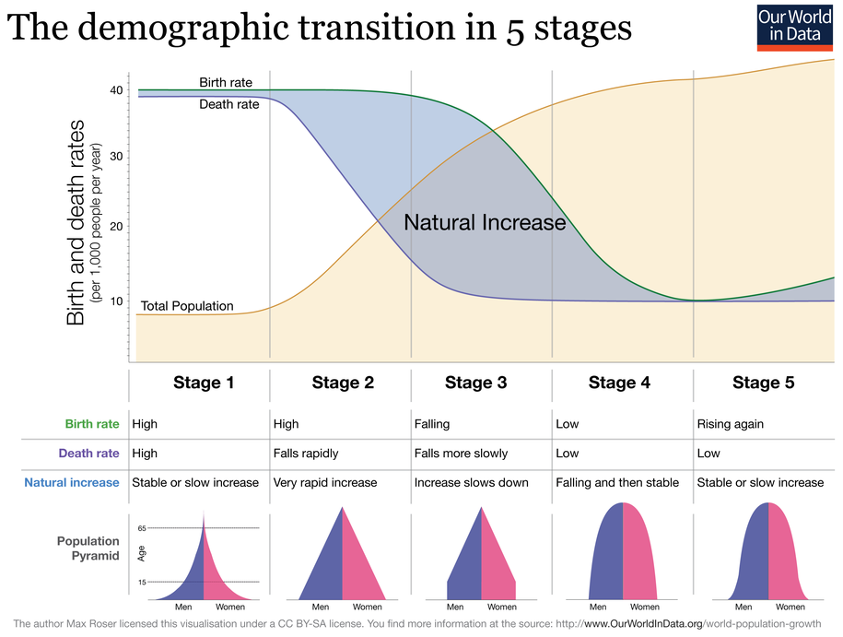prehensive Review (1989–2013) Int. J. Environ. Res. Public Health 2018, 15, 2266;

